

**TRIBHUWAN UNIVERSITY**

**INSTITUTE OF SCIENCE AND TECHNOLOGY**

**SUBMITTED TO :**

Aavash Khadka

Lecturer, E-Commerce

**SUBMITTED BY :**

Aayush Basnet

Nischal Kunwar

Utshav Paudel

A Project Report Submitted as required for E-Commerce (CSC 370)

Bachelor of Science in Computer Science & Information Technology (B.SC. CSIT)

6th Semester of Tribhuvan University, Nepal

**Project of E-Commerce “ Briskshya ”**

Date : 2025/02/15

**Table of Contents**

1. **Acknowledgement** 1
2. **Abstract** 2
3. **Introduction** 3  
     3.1 About the Project 3  
     3.2 Problem Statement 4  
     3.3 Objectives 4  
     3.4 Proposed Solution 5
4. **Requirement Analysis** 6  
     4.1 Functional Requirements 6  
     4.2 Non-Functional Requirements 6
5. **System Requirements** 7  
     5.1 Hardware Requirements 7  
     5.2 Software & Tools Used 8
6. **System Design** 9  
     6.1 Entity-Relationship Diagram (ERD) 9  
     6.2 Use Case Diagram 10
7. **Implementation** 11  
     7.1 Key Features 11  
       7.1.1 Product Catalog 11  
       7.1.2 Shopping Cart 11  
       7.1.3 PayPal Integration 12  
     7.2 Screenshots of Web Pages 12  
       7.2.1 Homepage 12  
       7.2.2 Product Page 14  
       7.2.3 Checkout Page 16

7.2.4 Myaccount Page 18

1. **Testing & SEO** 19  
     8.1 Basic Testing 19  
     8.2 SEO Strategies 20
2. **Conclusion and Future Scope** 20  
     9.1 Achievements 20  
     9.2 Limitations 20  
     9.3 Future Improvements 21
3. **References** 21

We would like to express our sincere gratitude to all those who supported and guided us throughout the development of our e-commerce project, **Brikshya**.

We are deeply thankful to our lecturer, **Mr. Aavash Khadka**, for his valuable guidance, continuous encouragement, and insightful feedback, which played a crucial role in the successful completion of this project.

We would also like to extend our gratitude to **Madan Bhandari Memorial College** for providing the necessary resources and a supportive environment that enabled us to carry out this project effectively.

Lastly, we are grateful to our families and well-wishers for their constant support and encouragement throughout the process.

**Acknowledgement**

**Abstract**

This project, titled **Brikshya**, is an e-commerce website designed to provide a platform for customers to purchase both **indoor** and **outdoor plants**. The website is developed using **WordPress** and the **WooCommerce** plugin, hosted locally on **XAMPP**. Additionally, the website integrates the **PayPal payment gateway** for secure online transactions.

The primary objective of **Brikshya** is to offer a convenient and user-friendly interface where customers can browse a variety of plants, add them to their cart, and proceed to checkout with ease. The website features product categorization, a shopping cart, user registration and login, and order tracking capabilities.

This project showcases the integration of modern web technologies to build a functional and aesthetically pleasing e-commerce platform, with a focus on security, smooth user experience, and seamless payment processing.

**3. Introduction**

**3.1 About the Project**

**Brikshya** is an innovative e-commerce platform designed to provide a wide selection of **indoor** and **outdoor plants** for customers who wish to enhance their living and working spaces. The name *Brikshya* is derived from the Sanskrit word *"Briksha,"* meaning "tree," symbolizing growth, nature, and sustainability.

The primary goal of **Brikshya** is to offer a seamless and user-friendly online shopping experience for individuals interested in purchasing plants. Whether you're a seasoned gardener or a beginner, **Brikshya** provides a variety of plants suited for different spaces, including indoor plants for homes and offices, and outdoor plants for gardens and patios. Each product on the platform includes detailed information about the plant’s care needs, helping customers make informed purchasing decisions.

The website is built using **WordPress** with the **WooCommerce** plugin, offering an intuitive interface for easy browsing and purchasing. Additionally, the integration of **PayPal** ensures secure and reliable payment processing for customers.

**3.2 Problem Statement**

In the current market, purchasing plants online can be a challenging experience for many consumers.

Several issues plague existing e-commerce platforms that offer plants:

* **Limited Selection and Poor Categorization**: Many online stores either lack a broad selection of plants or fail to categorize them effectively, making it difficult for customers to find specific types of plants.
* **Lack of Detailed Product Information**: Customers often struggle to find important details such as care instructions, ideal environments, and plant maintenance tips, leading to uncertainty about plant care.
* **Complex or Unintuitive Shopping Experience**: A lack of a well-designed and responsive website may lead to frustration, causing customers to abandon their purchases.
* **Security Concerns**: Online payments can raise concerns about data security, and customers need assurance that their financial transactions are safe.

**Brikshya** aims to solve these problems by offering a user-friendly, secure, and well-organized online platform. Customers will be able to easily browse a wide range of plants, access detailed care information, and complete purchases through a secure payment gateway, **PayPal**.

**3.3 Objectives**

The main objectives of the **Brikshya** project are as follows:

1. **User-Friendly Interface**: To create a website that is easy to navigate, enabling users to easily search for and find plants based on type (indoor or outdoor) and care requirements.
2. **Comprehensive Product Details**: To provide detailed plant descriptions, including care tips, ideal growing conditions, and maintenance guides, helping users make informed decisions.
3. **Secure Payment Processing**: To integrate **PayPal** as a trusted payment gateway, ensuring safe and secure transactions for customers.
4. **Mobile-Optimized Design**: To ensure that the platform is fully responsive, offering a smooth and accessible shopping experience across both desktop and mobile devices.

**3.4 Proposed System**

The **Brikshya** e-commerce platform is built on **WordPress** and powered by the **WooCommerce** plugin, providing the flexibility and scalability necessary for managing an online store. The system will offer the following key features:

* **Product Catalog**: Plants will be categorized into sections such as indoor plants, outdoor plants, and low-maintenance plants. Each plant will have a detailed product page featuring a high-quality image, price, and detailed care instructions.
* **Customer Accounts**: Users will be able to create accounts to track their orders, store shipping details for quicker checkout, and view their order history.
* **Secure Checkout**: The checkout process will be simple, offering secure payment through **PayPal** for safe online transactions.
* **Mobile Compatibility**: The website will be designed to work smoothly on both desktop and mobile devices, ensuring users can shop from anywhere, at any time.

The **Brikshya** platform will aim to provide a convenient, efficient, and safe shopping experience for customers interested in purchasing plants, making it easier to bring nature into their homes and workplaces.

**4. Requirements Analysis**

**4.1 Functional Requirements**

The functional requirements define the core functionalities and features of the e-commerce website **Brikshya**. These include:

1. **User Registration and Login**: Customers can create accounts, log in, and manage their profiles.
2. **Product Catalog**: The website should display a categorized list of indoor and outdoor plants.
3. **Product Details**: Each product should have a dedicated page showing detailed information like description, price, and images.
4. **Shopping Cart**: Customers can add products to their shopping cart, view items, update quantities, or remove products.
5. **Order Placement**: Customers can place orders by providing necessary details (shipping address, payment).
6. **Order Management**: Admin can view, update, or cancel orders.
7. **Payment Integration**: The website integrates with PayPal for secure online payments.
8. **Search and Filter**: Customers can search for specific products and filter based on category or price.

**4.2 Non-Functional Requirements**

Non-functional requirements focus on system performance and user experience. These include:

1. **Usability**: The website should be intuitive and user-friendly, with easy navigation for both customers and admins.
2. **Performance**: The system should ensure fast load times (under 3 seconds) even with a moderate number of concurrent users.
3. **Scalability**: The website should be able to handle an increasing number of products, users, and orders as the business grows.
4. **Reliability**: The system must be available 24/7 with minimal downtime, ensuring smooth operations.
5. **Security**: All customer data, including personal information and payment details, should be protected through secure connections (HTTPS) and payment gateway encryption.
6. **Compatibility**: The website should work seamlessly across different devices and browsers (Chrome, Firefox, Safari, mobile devices).

**5. System Requirements**

**5.1 Hardware Requirements**

For the local setup and deployment of the **Brikshya** website, the following hardware requirements are recommended:

* **Web Server**: A computer or server with a minimum of 4GB RAM and 50GB of free disk space to host the website, plant images, and the database.
* **Processor**: Intel Core i5 or equivalent, with at least 2 cores, to ensure smooth operation of the XAMPP local server environment.
* **Backup Storage**: External or cloud-based storage for regular backups of plant product data, images, and user orders.

**5.2 Software & Tools Used**

The following software and tools were utilized to build and deploy the **Brikshya** website, which sells indoor and outdoor plants:

|  |  |
| --- | --- |
| Software/Tool | Purpose |
| XAMPP | Provides a local server environment with Apache, MySQL, and PHP. Used to host and run WordPress and WooCommerce locally during development and testing. |
| WordPress | Content management system (CMS) for building and managing the Brikshya website, including plant product pages, content, and administrative functions. |
| WooCommerce | E-commerce plugin for WordPress that enables product listings (indoor and outdoor plants), shopping cart, checkout, and order management features. |
| PayPal Integration | Payment gateway integrated into WooCommerce for securely processing payments for plant purchases. |
| PHP | Server-side scripting language used for dynamic content and backend management on the website. |
| MySQL | Database management system, included with XAMPP, used for storing product details, user data, and orders. |
| Web Browser | For testing the website and ensuring compatibility across different browsers (e.g., Google Chrome, Firefox, Safari). |

**6. System Design**

This section outlines how the Brikshya e-commerce website is structured and how users interact with it. It explains the flow of data, the relationship between key components, and the various functions performed by users such as browsing plants, placing orders, and making payments. Visual diagrams are used to represent the internal structure and external interactions of the system, helping to understand how the website operates both from a user and backend perspective.

**6.1 Entity- Relationship Diagram(ERD):**  
 Describes how data is organized in the system. It includes main entities like Users,Products, Orders, and Payments, and shows how they are linked—for example, a user can include placing multipleorders, and each order includes one or more products.

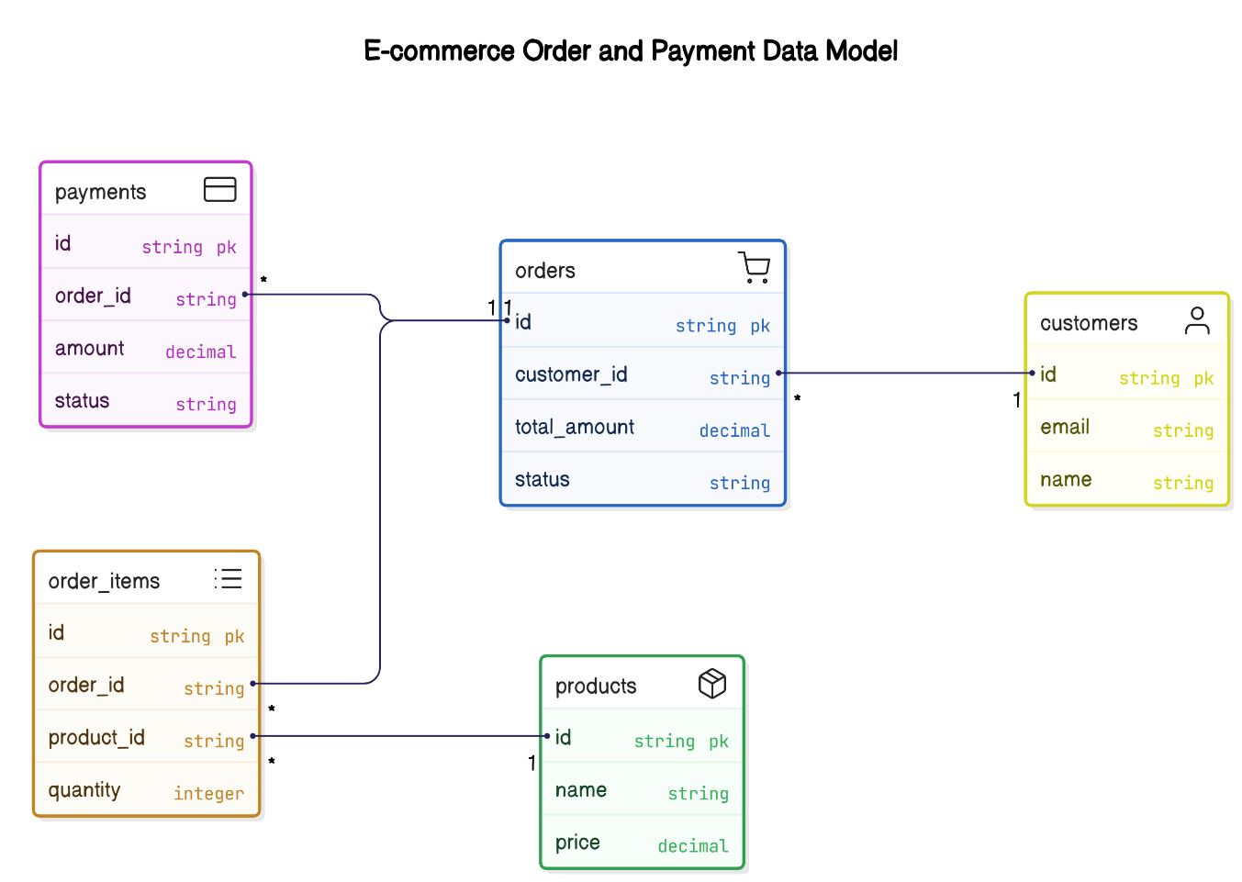

Fig:ERD Diagram

**6.2 Use Case Diagram:**

Illustrates the actions that users (customers and admin) can perform in the system. Customers can browse, register, place orders, and make payments, while the admin can manage products, view orders, and update inventory.

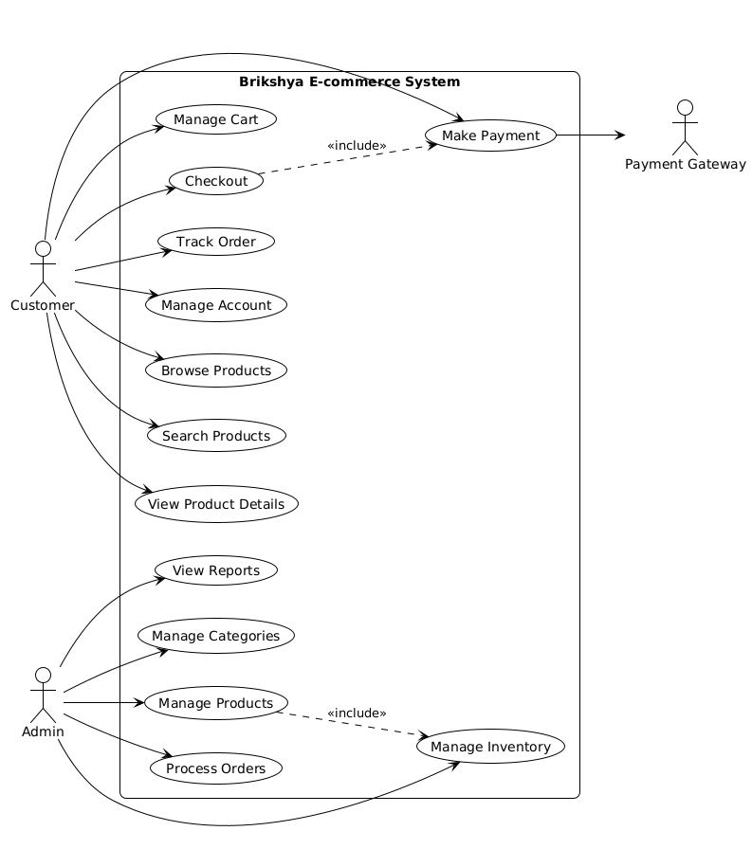

Fig:Use Case Diagram

**7.Implementation**

The platform was built using WordPress and the WooCommerce plugin, leveraging their functionalities to meet the project's objectives. Key features were implemented to ensure a user-friendly shopping experience, secure transactions, and effective product presentation. The development was carried out locally using the XAMPP environment.

**7.1 Key Features**

The core functionalities of the Brikshya website were implemented as follows:

**7.1.1 Product Catalog**

The product catalog was created using WooCommerce's product management features. Plants were added as individual products, categorized into "Indoor Plants" and "Outdoor Plants" for easier navigation. Each product entry includes:

* A descriptive title (e.g., "Snake Plant," "Rose Bush").
* High-quality images showcasing the plant.
* A detailed description covering characteristics and basic care tips, fulfilling the objective of providing comprehensive information.
* The price of the plant.
* Relevant categories and tags to aid searching and filtering.

This setup allows customers to browse the available selection easily and access necessary details directly on the product page.

**7.1.2 Shopping Cart**

The shopping cart functionality is powered by WooCommerce's built-in system. Users can:

* Add desired plants to their cart directly from the product or shop pages using an "Add to Cart" button.
* View the contents of their cart at any time via the cart icon/page.
* Adjust the quantity of items or remove items from the cart.
* See a subtotal of their selected items before proceeding to checkout.

This provides a standard and intuitive e-commerce cart experience.

**7.1.3 PayPal Integration**

To ensure secure payment processing, PayPal was integrated as the primary payment gateway. This was achieved by:

* Installing and activating a compatible PayPal payment gateway plugin for WooCommerce.
* Configuring the plugin with the necessary PayPal account credentials (sandbox or live, depending on the testing phase).
* Enabling PayPal as a checkout option.

During the checkout process, users selecting PayPal are securely redirected to the PayPal platform to complete their payment, after which they are returned to the Brikshya website for order confirmation. This meets the objective of secure payment processing.

**7.2 Screenshots of Web Pages**

The following subsections provide visual examples of the implemented Brikshya website's user interface, showcasing the key pages involved in the customer journey.

**7.2.1 Homepage**

**

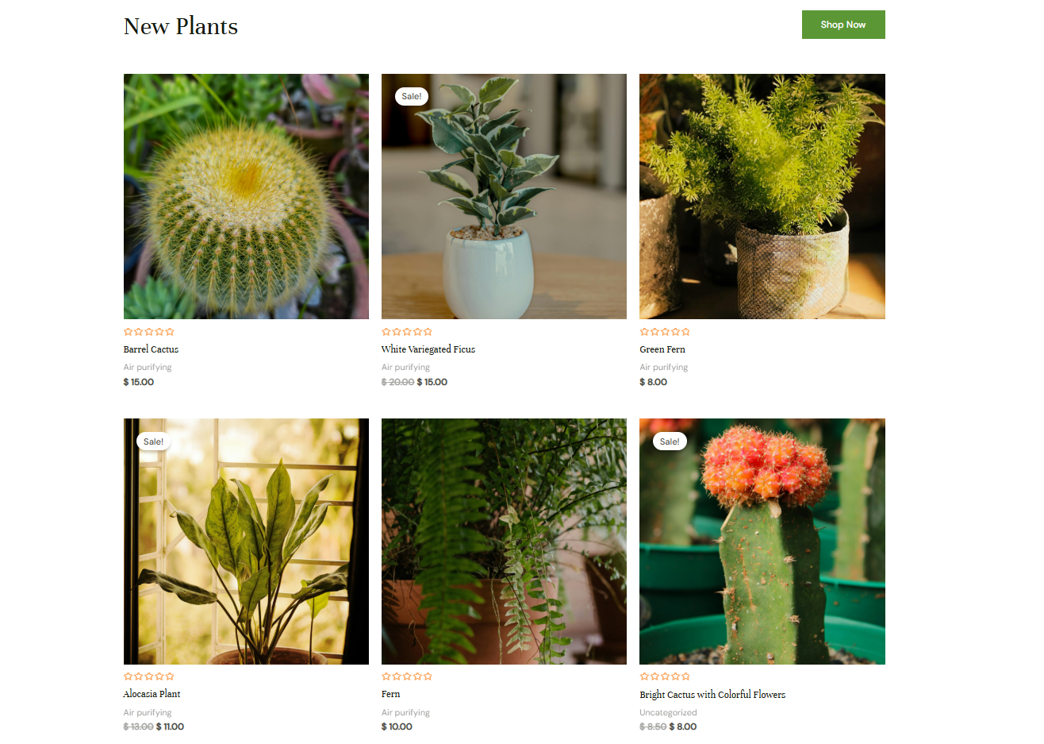 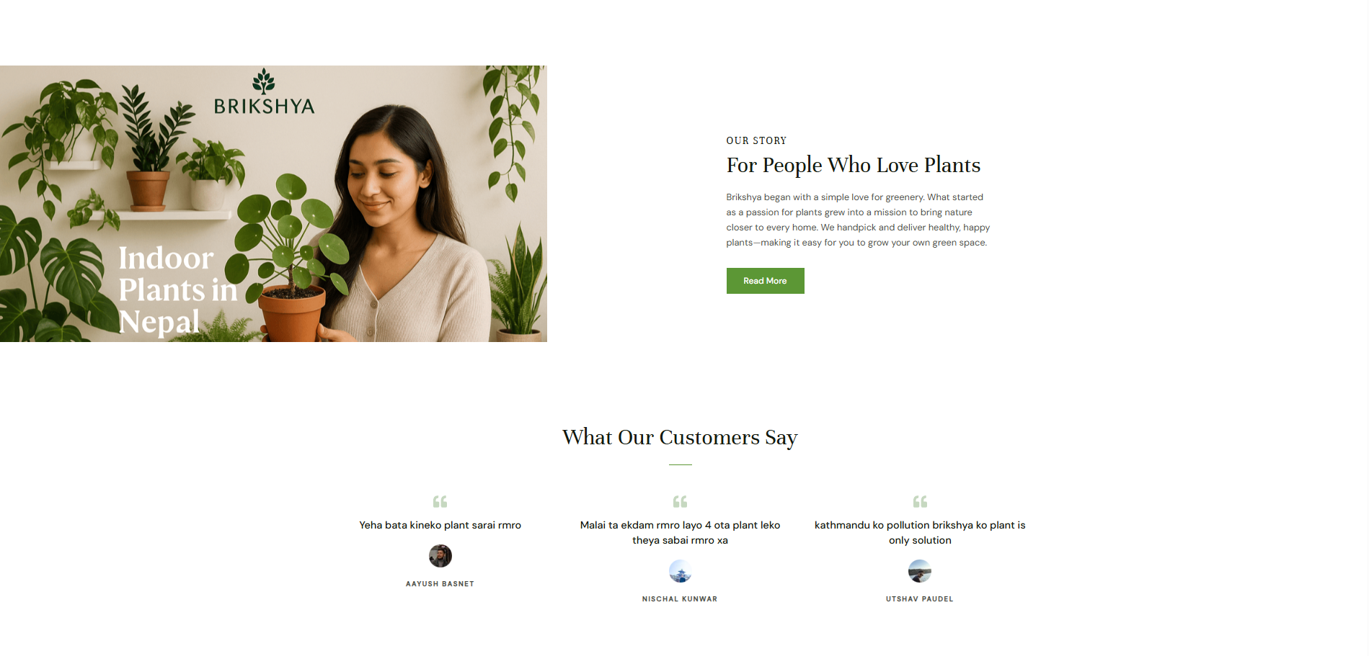

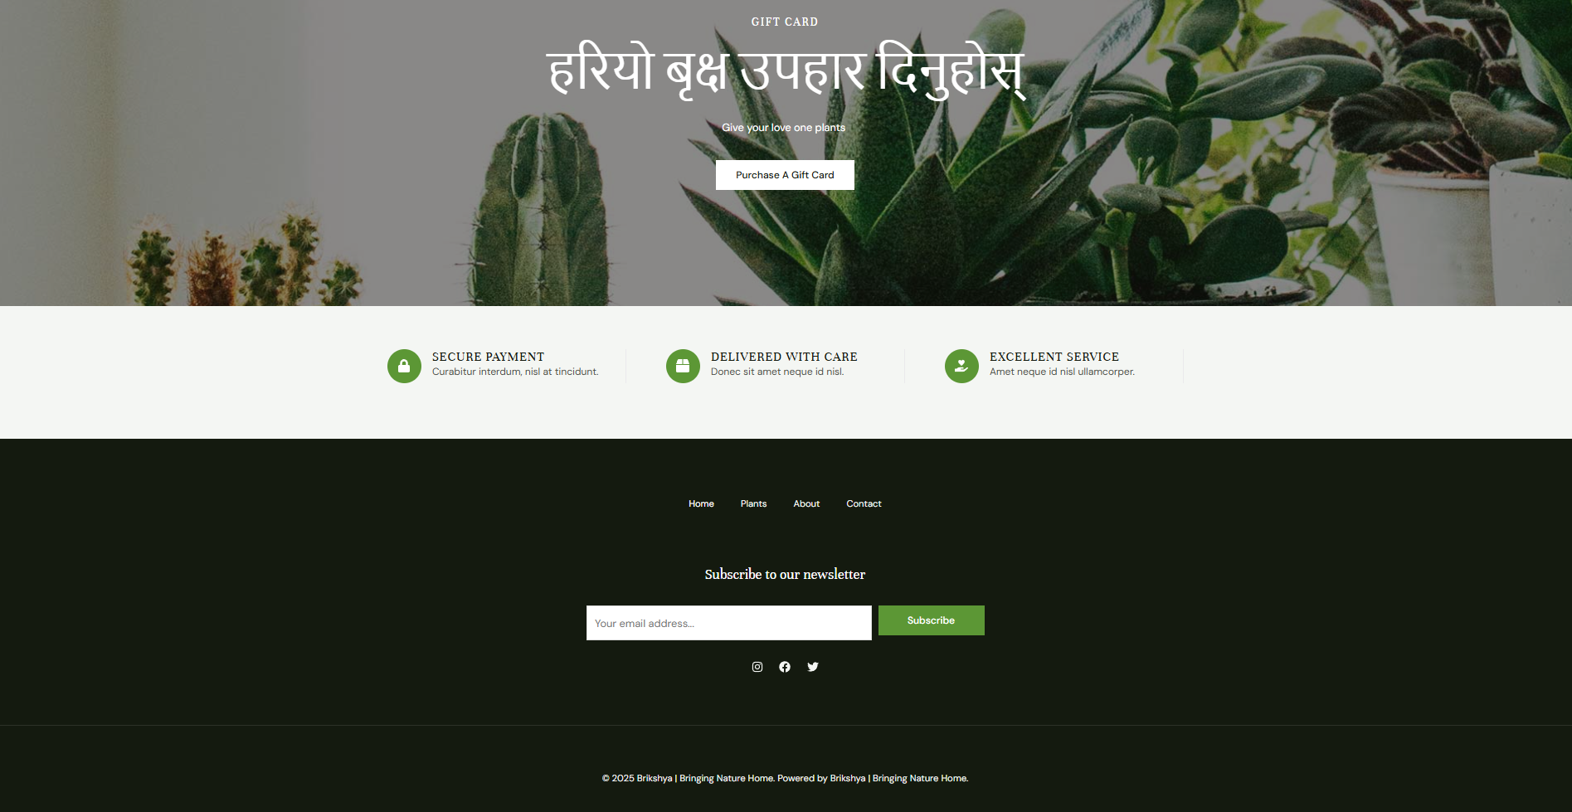

**7.2.2 Product Page**

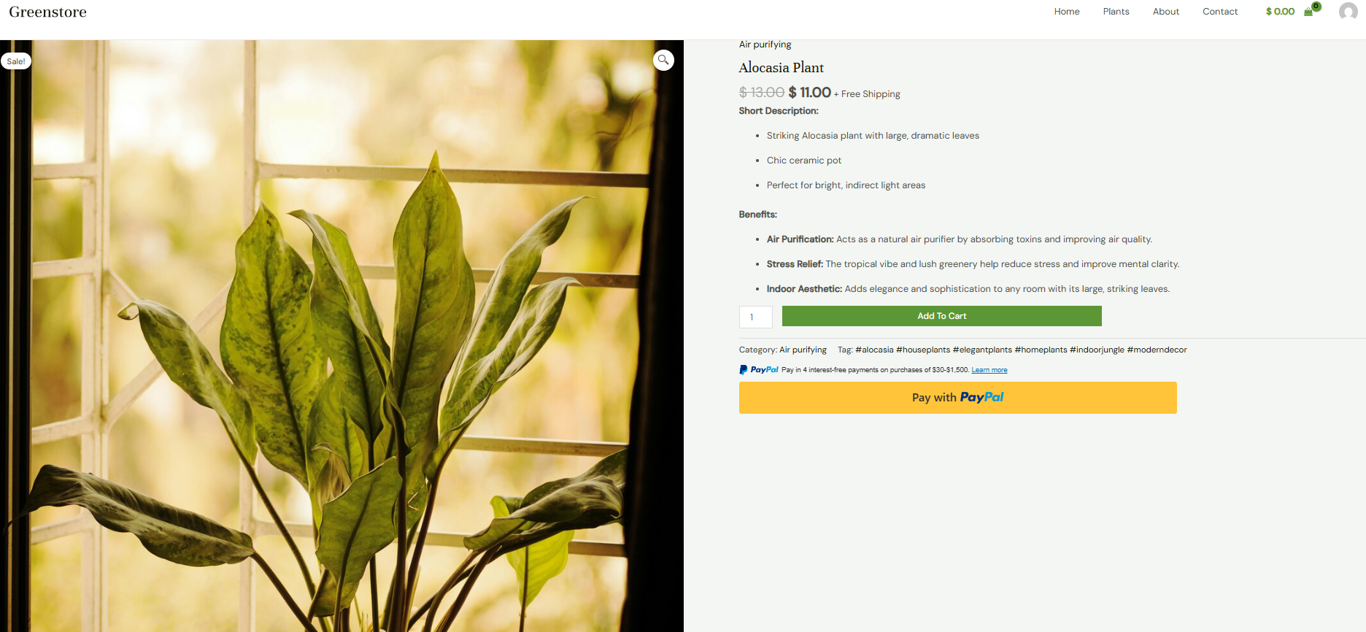

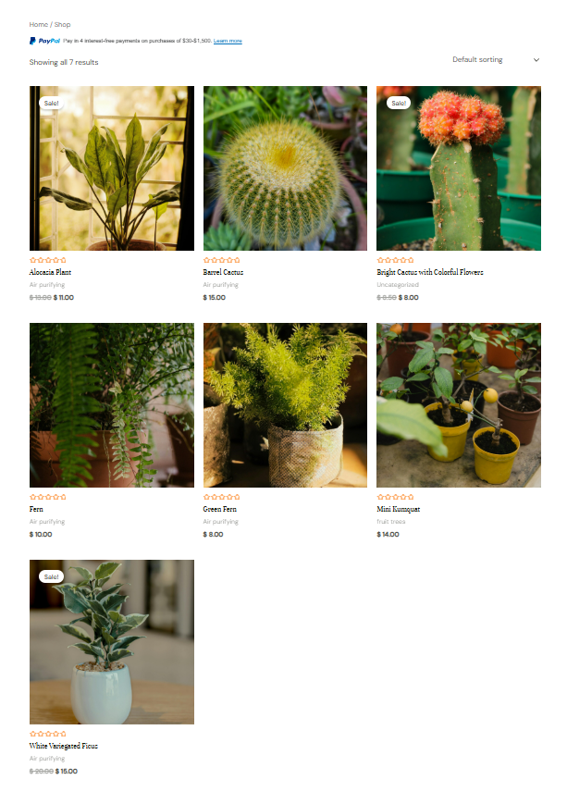

**7.2.3 Checkout Page**

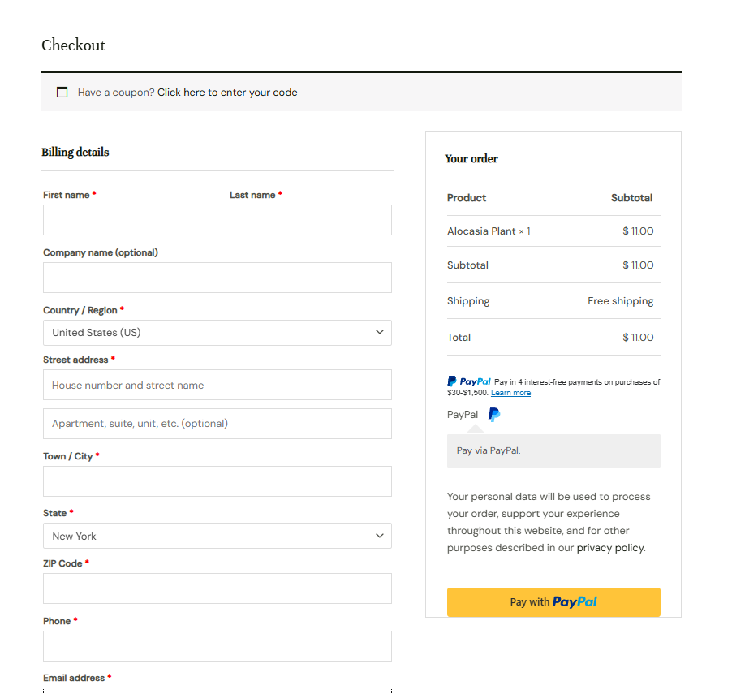

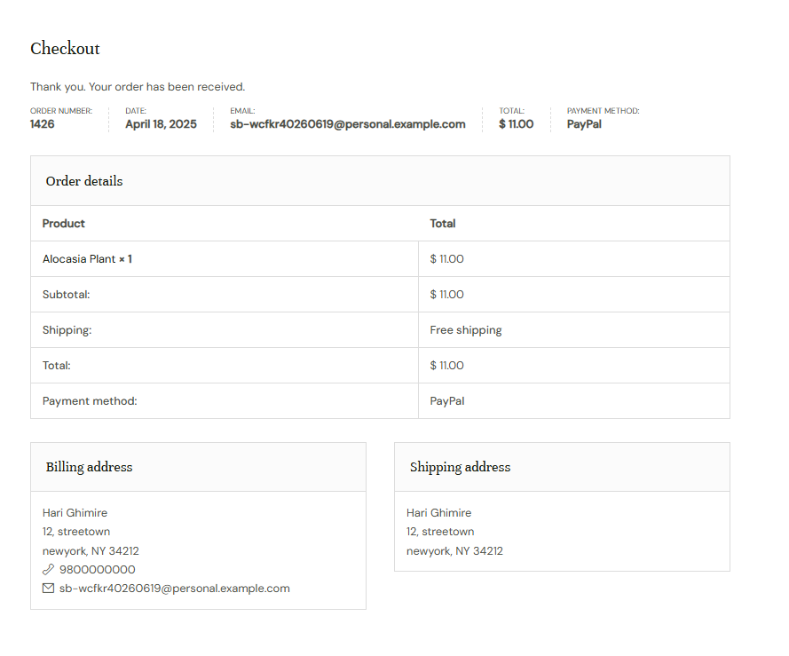

**7.2.3 My account Page**

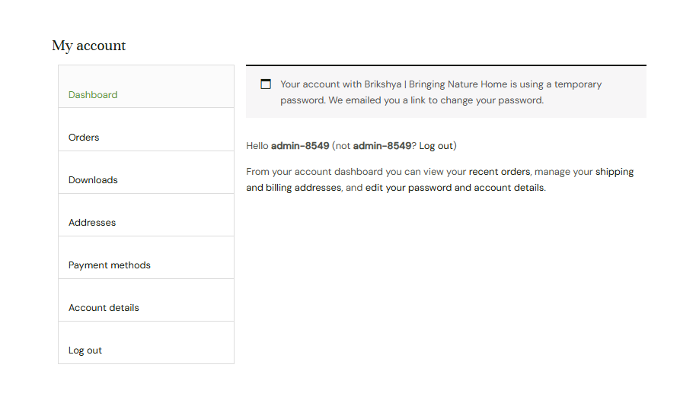

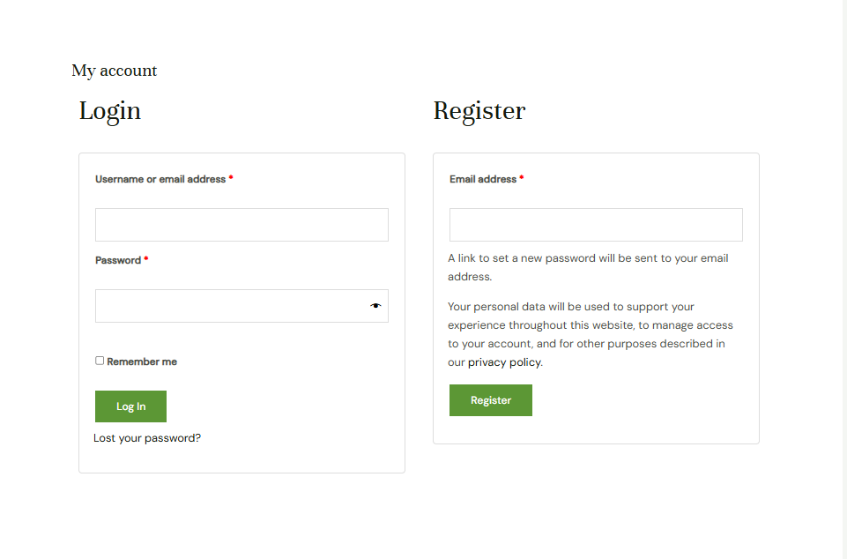

**8. Testing & SEO**

This section includes basic testing activities performed to ensure the core functionalities of the website work as expected, along with basic SEO strategies applied to improve visibility on search engines.

**8.1 Basic Testing**

|  |  |  |
| --- | --- | --- |
| Test Case | Expected Result | Status |
| User Registration | New user can register with valid details | Passed |
| User Login | Registered user can log in successfully | Passed |
| Browse Products | Products are displayed correctly on the homepage | Passed |
| Add to Cart | Selected products are added to the cart | Passed |
| Remove from Cart | Products can be removed from the cart | Passed |
| Checkout Process | User can proceed to checkout | Passed |
| PayPal Payment Integration | User is redirected to PayPal and payment completes | Passed |
| Admin Product Management | Admin can add/edit/delete products | Passed |
| Responsive Design Test | Website works well on mobile and desktop | Passed |

**8.2 SEO Strategies**

* **Meta Tags:** Added relevant title and description tags to web pages.
* **Keyword Optimization:** Used plant-related keywords (e.g., indoor plants, outdoor plants) in content.
* **Image Alt Text:** Provided alt tags for product images to boost search visibility.
* **Mobile Friendliness:** Ensured responsive design for better SEO ranking.
* **Readable URLs:** Used SEO-friendly URLs through WordPress permalink settings.

**9. Conclusion and Future Scope**

This section outlines the key accomplishments of the Brikshya project, acknowledges its current limitations, and presents suggestions for future enhancements.

**9.1 Achievements**

* Developed a fully functional e-commerce website for selling indoor and outdoor plants.
* Utilized WordPress along with WooCommerce for efficient product and order management.
* Integrated PayPal to enable secure online payment transactions.
* Ensured basic mobile responsiveness and implemented fundamental SEO strategies.
* Designed a clean and user-friendly interface to enhance customer experience.

**9.2 Limitations**

* Website is currently running locally through XAMPP and is not publicly hosted.
* Only PayPal is available as a payment option, limiting accessibility for some users.
* Features such as inventory tracking, delivery system, and user reviews are not yet included.
* The admin dashboard lacks advanced analytics and reporting functionalities.

**9.3 Future Improvements**

In order to further improve the Brikshya platform, the following enhancements are suggested:

* It is recommended to host the website on a live server, allowing real-time public access and increasing its availability to a wider audience.
* To provide more convenience for local users, it would be beneficial to integrate additional payment gateways such as eSewa and Khalti.
* Adding features like order tracking, customer reviews, and plant care blogs will help enhance user engagement and offer added value to customers.
* Strengthening the admin panel with features such as detailed analytics, inventory control, and sales reports will help streamline operations and improve decision-making.

**References**

1. **WordPress.org**. *WordPress*. <https://wordpress.org>
2. **WooCommerce**. *WooCommerce: The most customizable eCommerce platform for building your online business*. <https://woocommerce.com>
3. **PayPal Developer**. *PayPal Developer Documentation*. https://developer.paypal.com/docs/
4. **Apache Friends**. *XAMPP for Windows*. https://www.apachefriends.org/index.html
5. **ThemeIsle**. *How to Install XAMPP and WordPress Locally on Windows PC*. <https://themeisle.com/blog/install-xampp-and-wordpress-locally/>
6. **Cloudways**. *How to Set up PayPal for WooCommerce in 2025 | In-Depth Guide*. https://www.cloudways.com/blog/paypal-for-woocommerc